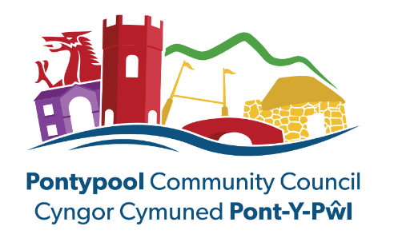

JOB DESCRIPTION

DESIGNATION: PROJECTS AND EVENTS MANAGER

GRADE: 7 (SCP 24 TO 28)

HOURS OF WORK: 30 HRS PER WEEK (Flexible working hours in operation, this is subject to the requirements of the Council)

RESPONSIBLE TO: THE CLERK OF THE COUNCIL

PLACE OF WORK: PONTYPOOL COMMUNITY COUNCIL, 35A COMMERCIAL STREET, PONTYPOOL

PURPOSE OF JOB: TO MANAGE AND OVERSEE ALL COUNCIL EVENTS AND PROJECTS. TO BE RESPONSIBLE FOR AND MANAGE THE PROJECTS & EVENTS OFFICER.

LIAISON WITH: ALL STAFF, COUNCILLORS, SUPPLIERS, EXTERNAL AND PARTNER ORGANISATIONS AND THE PUBLIC

KEY DUTIES & RESPONSIBILITIES

- To oversee and manage the arrangements for all Council activities, projects, events.

- To be responsible for and manage the Projects & Event Officer.

- To be responsible for the development of existing projects and new project ideas for the Council, in liaison with the Clerk.

- To play an integral part in the development and delivery of the council’s community engagement strategy.

- To be responsible for ensuring that relevant Risk Assessments are carried out for all Council’s Projects and Events within the remit of the Community Council.

- To ensure that projects and events are joined up, innovative, quality driven, customer-focussed and aligned to the Council’s strategic objectives.

- To manage the budgets associated with each Project and Event and ensure the budget spend is monitored.

- To develop and maintain effective relationships with relevant stakeholders to support the development of Councils objectives.

- To act as Health and Safety Champion within the office environment assisting the Health and Safety Lead Officer and the Clerk on actions/recommendations necessary.

- To be familiar with and use relevant technology; and to make recommendations with regard to improvements in systems to increase accuracy, efficiency and effectiveness, and reduce costs.

- To produce reports on all events and projects and present such reports to the relevant committees when required.

- To cover reception as and when necessary, in the absence of the Administrative Officer.

- To support other staff and carry out all other reasonable duties as required by the Clerk and Deputy Clerk.

- To update the Council website and social media sites as appropriate.

- To be responsible for own health and safety and to promote compliance by others to ensure a safe working environment.

- To assist the Clerk in preparing and collating information for the Annual Report.

- To attend meetings which may be outside of your normal hours and take minutes when required.

- To undertake training and/or attend relevant courses deemed necessary and appropriate.

Please note: all roles within the council may be subject to possible changes in the future.

Projects & Events Manager

Person Specification

Skills and Abilities:

The ability to work as part of a team, showing a willingness to assist others and a commitment to meet the objectives of the team

- Previous knowledge of Projects and Events management.
- Events Training and/or Qualification or be willing to work towards.
- To hold a relevant Health & Safety Qualification (Level 3) or willingness to work towards.
- A good standard of written English, numeracy and IT skills.
- To supervise and coordinate the work of others.
- To interpret data in order to draw conclusions and make appropriate recommendations.
- To manage budgets.
- To write committee reports effectively.
- To use technology effectively.
- To develop and produce spreadsheets.
- To provide management information that supports the Council in effectively managing its resources.
- To communicate well in a manner appropriate to individual needs, in person, by phone or in writing.
- To apply a methodical approach and to follow procedures.
- To organise and prioritise own workload.
- To work using own initiative.

Personal Attributes:

- A high level of attention to detail and accuracy
- The ability to work as part of a team, showing a willingness to assist others and a commitment to meeting the objectives of the team
- A personal commitment to the work of the Council, taking ownership of tasks and seeking to meet set deadlines and targets
- Flexibility to attend evening and weekend meetings and events
- A commitment to personal development
- A positive attitude to new challenges and a willingness to adapt quickly to change

