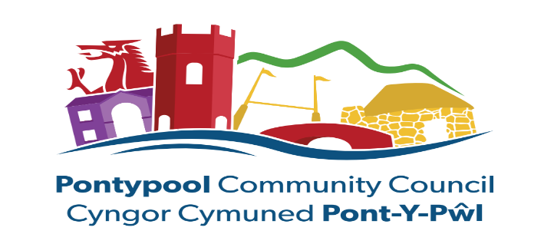

COMMUNITY HALLS AND COMMUNITY FACILITIES FUNDING - GRANT AID

Pontypool Community Council is aware that some Community groups which look after a building are incurring costs such as utility bills, insurance, emergency repairs etc which have significantly increased over the past years. The Council wants to offer support to these organisations.
Please find enclosed a Community Halls and Facilities application form for you to complete and return. The questions which are not related to finance are to see if there is any other support the Council can offer or signpost to other organisations that may help. The questions are NOT to judge your application.
Alongside your completed application form please also submit your organisations Income and Expenditure and please include the balance sheet of your last audited accounts.
Please return the form no later than 24th October 2025 for consideration at the November meeting. Applications submitted after this time will not be considered.
The Council sets a budget for these grants at its annual budget meeting. Council recognises the tremendous amount of work done by volunteers who run community halls and other facilities and does not judge the relative levels of work done by different organisations. The amount of money the Council can give is therefore based on the amount in the budget and the number of applications.

